Assign CURD Project For My Impact Meter

*Undertaken by:*

**Abdul Hanan**

**Raheel Ghafoor**

*Supervised by:*

**Faisal Rahman (CTO)**



**Frontend**

**Signup Page:**

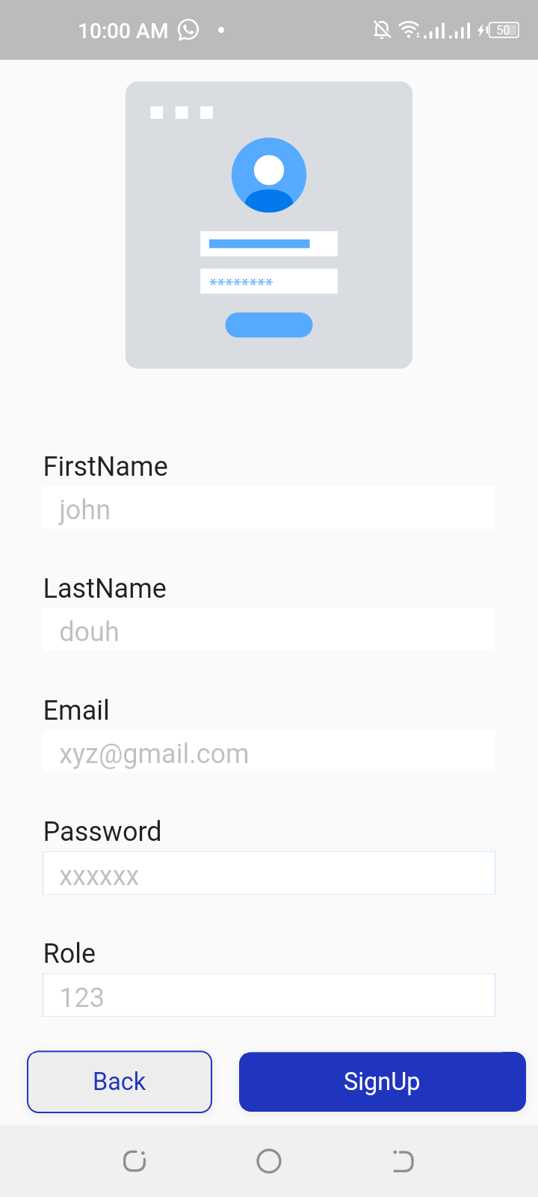

**Description:**

**Components** Signup Lottie Animation, Text Form Field (First Name, Last Name, Email, Password, Role), Buttons (Signup, Back).

**Working** User click on signup text on login page to redirect signup page blinking cursor on the first name by default using focus node. User enter his/her information in form fields and then click on signup button to register him successfully

if user click on back button he/she will go back to login page.

**API** When user click on the signup button it will hit the signup API call which result in gives the success true and leads to the login page.

**Login Page:**

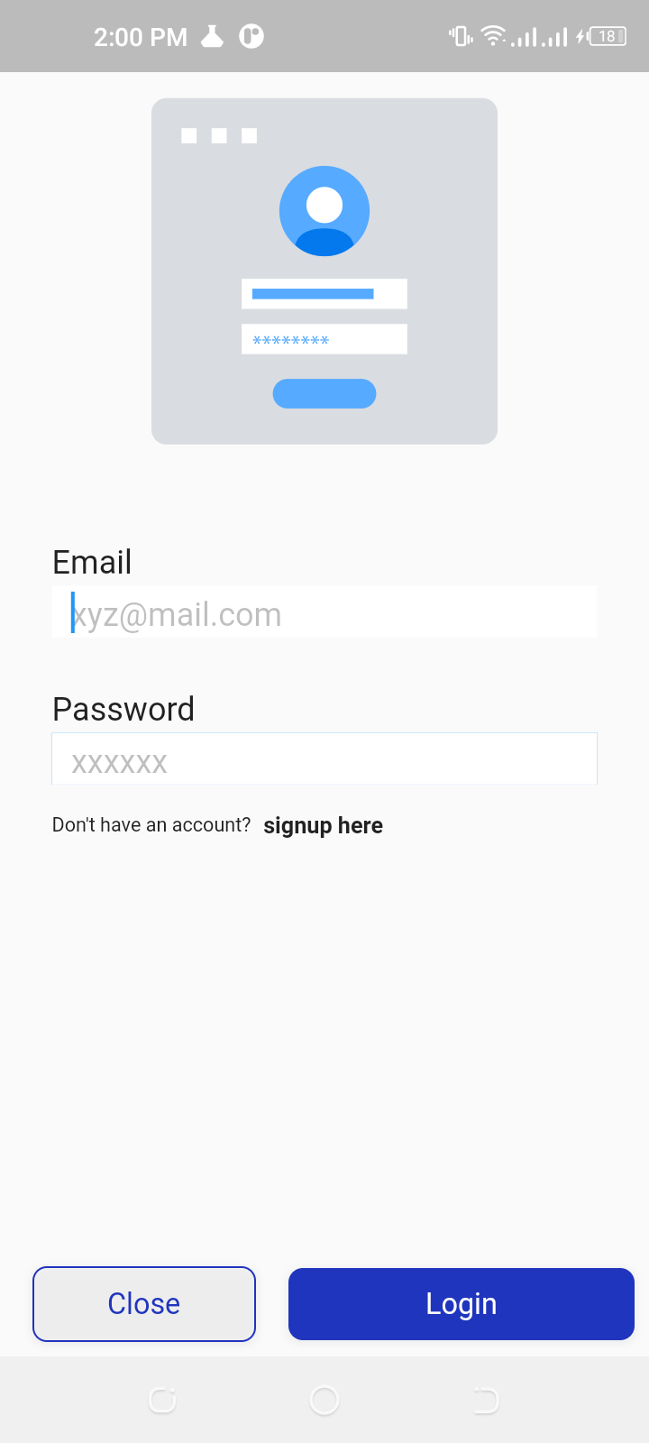

**Description:**

**Components** Login Lottie Animation, Text Form Field (Email, Password), Buttons (Login, Close).

**Working** After Signup page user redirect on login page blinking cursor on the email by default using focus node. User enter his/her email or password in form fields and then click on login button to redirect him/her to the home page if user click on close button application will be closed.

**API** When user click on the login button it will hit the login API call which result in gives the success true and leads to the home page.If the success false, then it will show an invalid credential pop up message.

**Home Page:**

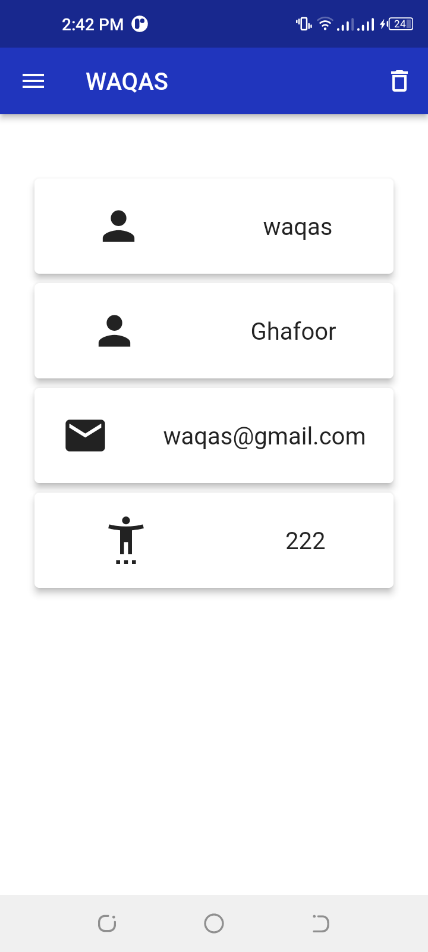

**Description:**

**Components** App Bar, Drawer, Delete Button, Cards, Icons, Texts.

**App Bar:** User Name, Drawer button, Delete button.

**Drawer:** User Profile header click on to navigate update profile page.

**Delete Button:** On click delete button user delete his/her account.

**API** When user redirect to home page before loading the home page getuserprofile API call which give the user information and then It will display on the home page at different section

**Update Page:**

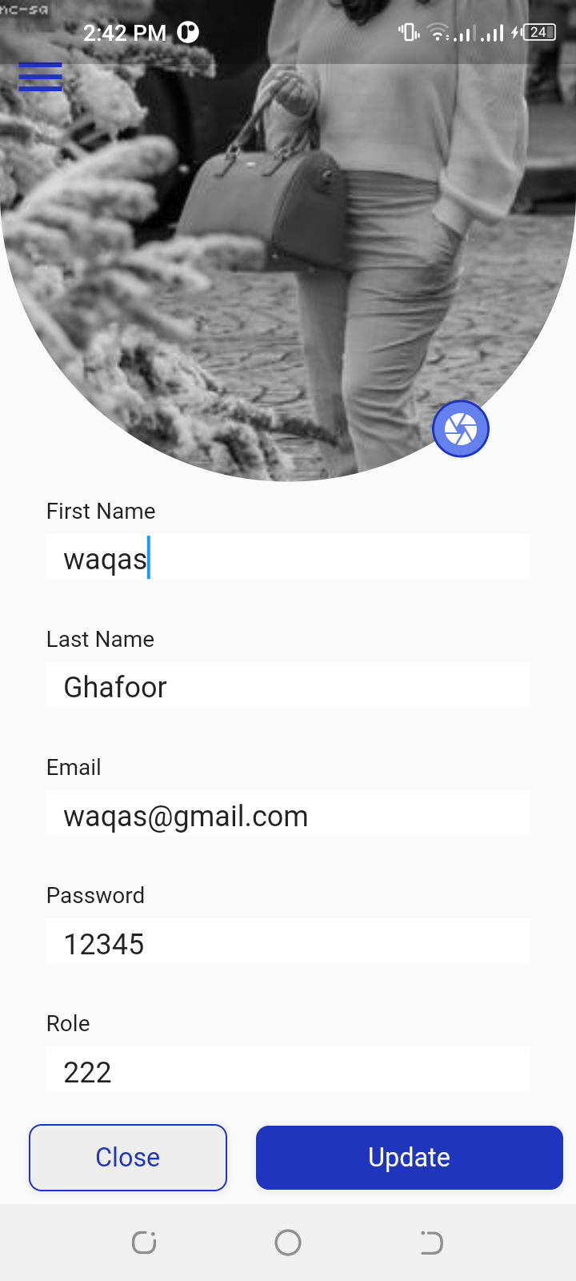

**Description:**

**Components** Profile Picture, Text Form Field (First Name, Last Name, Email, Password, Role), Buttons (Update, Close).

**Working** After Home page user redirect on profile page blinking cursor on the first name by default using focus node. User update his/her information in form fields and then click on update button to redirect him/her to the home page if user click on close button application will be closed.

**API** When user redirect to profile page before loading the profile page getuserprofile API call which give the user information and then It will display on the profile page text form field. So user can edit it, after edit the details and click the update button which hit call on update profile API and update the user and redirect to the home page.

**Delete User:**

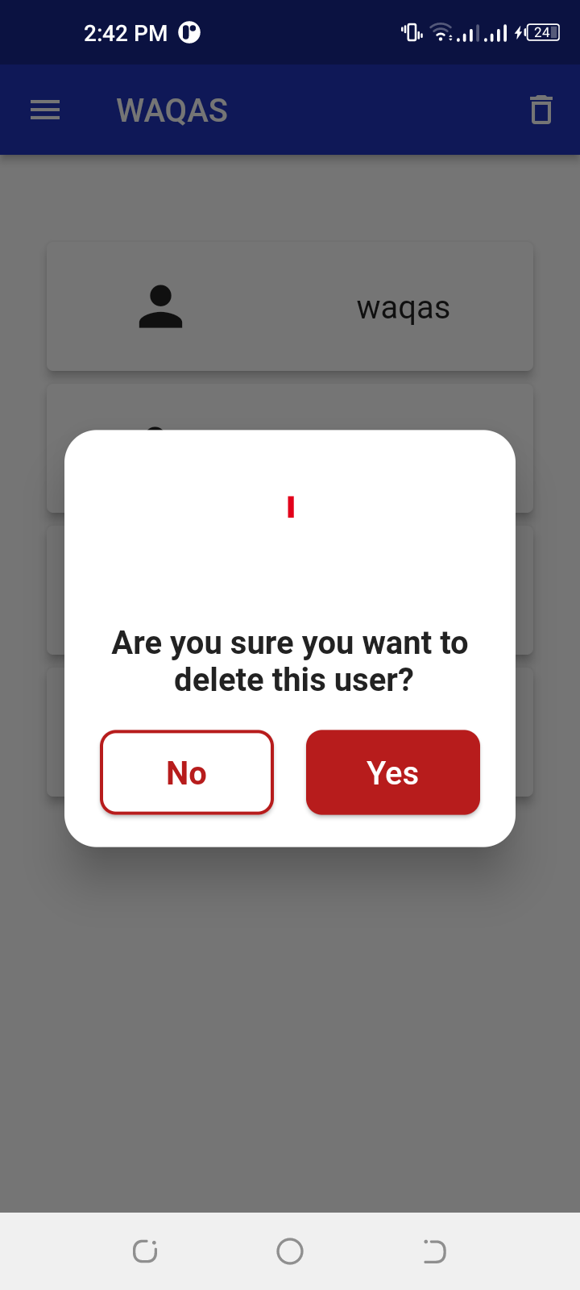

**Description:**

**Components** Delete button.

**Working** User click on delete button it will show conformation message. If user click on (yes button) then user delete successfully and user logout from device. If user click on (no button) then it will stay on home page.

**API** When user click on the delete button it will show confirmation message and if user click on yes it will call the delete API and then user delete and logout from the app.



**MiM Backend Development Team:**

* **Muhammad Usman**
* **Zohaib Akhtar**

**Date: 02/10/2022**

**Registration API:**

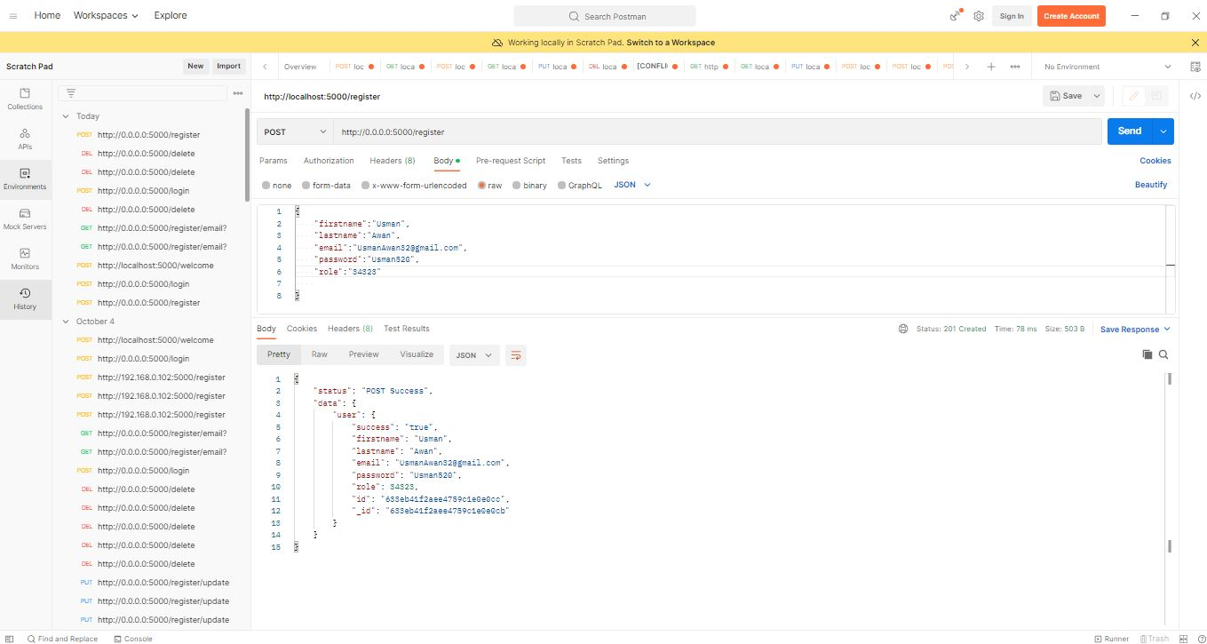

**API’s:** Register/Signup**:**

**Descriptions:** Postman Testing,

App Listening link**:** http://localhost:5000/**register**

Create a User account details(name,email,password etc.), select the JSON format and then select POST button(for creation of user data in Mongo dB or any database) and click on send button for sending request,  
Response :You will find the response against forwarded request in the below and will also find the **Status POST Successful or ‘Error your Email is already registered’**.

**Login API:**

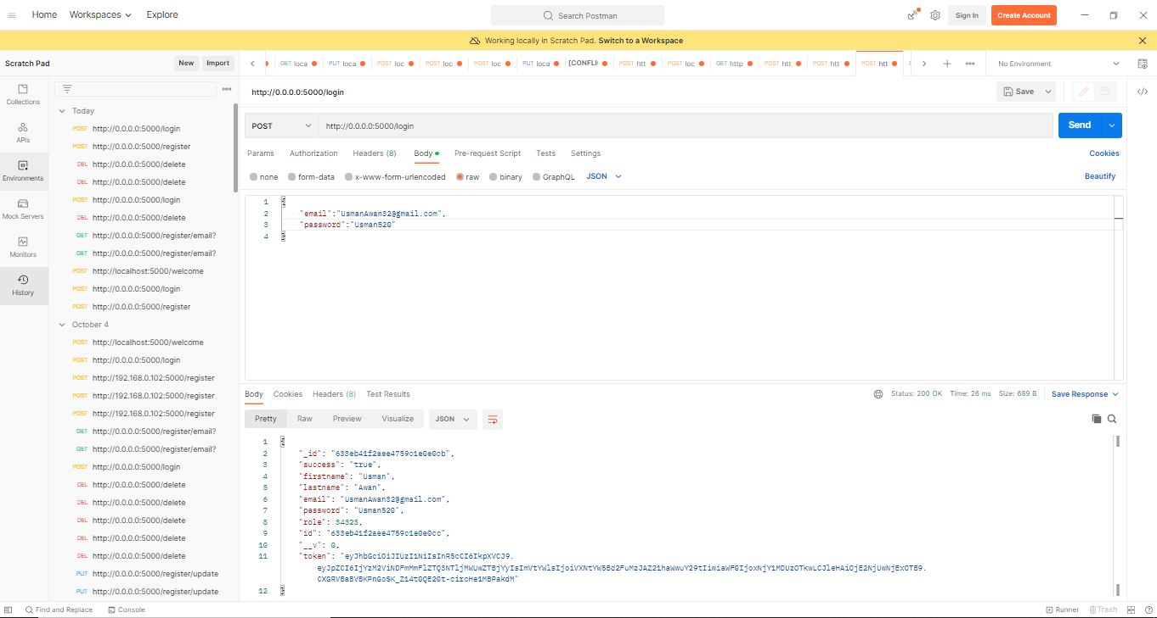

**API’s:** Login/Sign in**:**

**Descriptions:** Postman Testing,

App Listening link:http://localhost:5000/**login**

Create your registered Email and Password in the JSON format, and then select POST button(for login credential) and click on send button for sending request,  
Response : You will find the response against your correct Email and password in the below(postman section) and will also find the **Status POST Successful with Token(token is created for user authentication purpose) or Error ‘The email or password is incorrect’.**

**Token Verify API:**

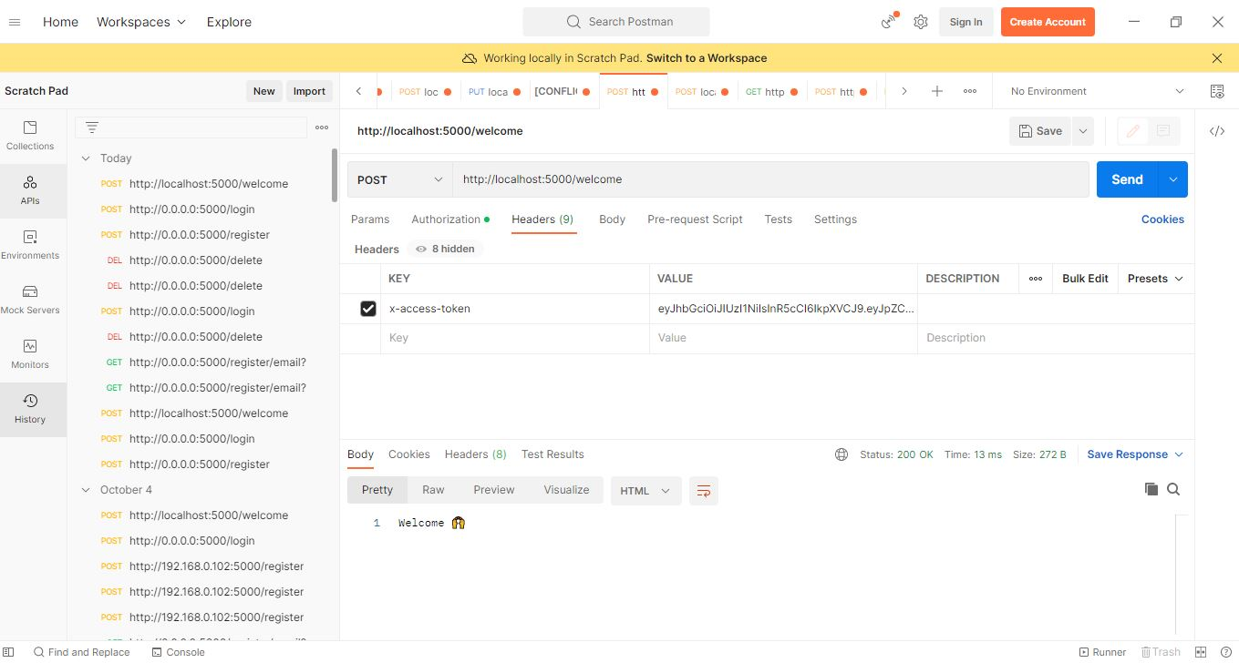

**API’s:** Verification via Token**:**

**Descriptions:** Postman Testing,

App Listening link:http://localhost:5000/**welcome**

Create your Key and Value in the Header section, Key(x-access-token) and Value(Your Token) and then select POST button(for Token verification request) and click on send button for sending request,  
Response : You will find the response against your key and Token in the below(postman section) and will also find the **Status Welcome(Successfully login) or Error Invalid Token.**

**Get API:**

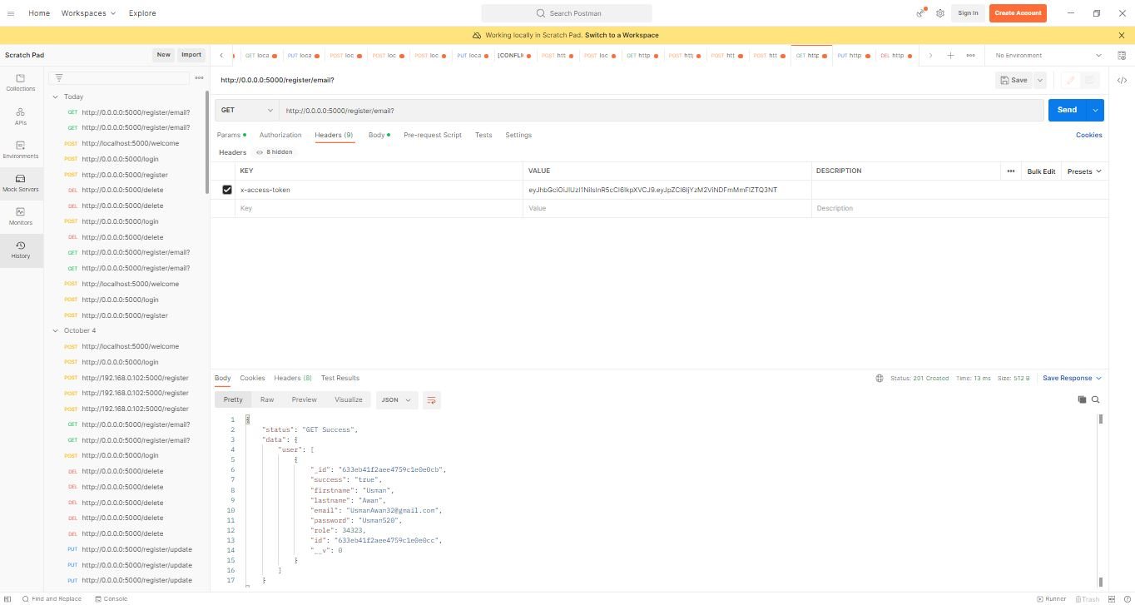

**API’s:** Get Request with token verification**:**

**Descriptions:** Postman Testing,

App Listening link:http://localhost:5000/

Create your Key(x-access-token) and Value(Your Token)in the Header section and then select Get button(for sending request with token verification) and click on send button for sending request,  
Response : You will find the login response against your key and Token in the below(postman section) and will also find the **Status (Successfully login) or Error Invalid Token.**

**Put API:**

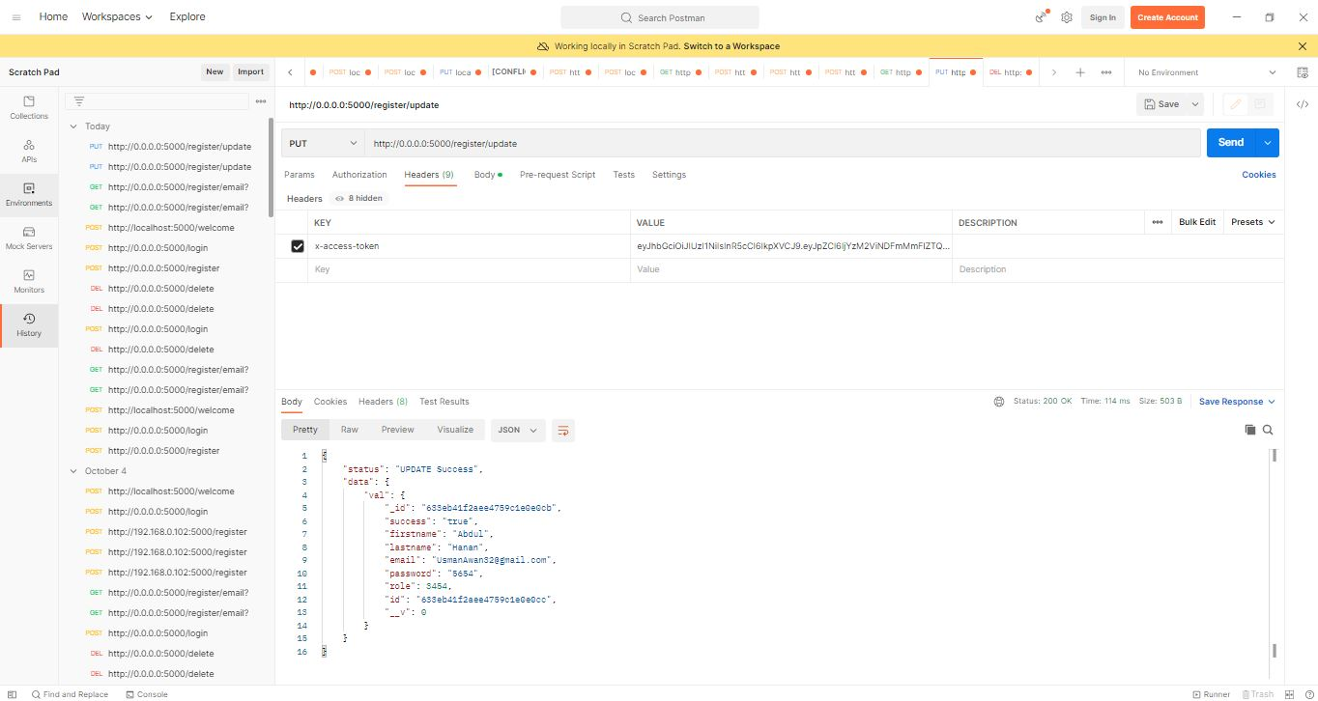

**API’s:** Update User Data**:**

**Descriptions:** Postman Testing,

App Listening link:http://localhost:5000/**register/update**

Create your Key(x-access-token) and Value(Your Token)in the Header section, make changes against your register JSON format and then select PUT button(for updating request with token verification) and click on send button,  
Response : You will find the updating request response against and **Status (Updated Successfully) or Error Invalid Token.** Updated data can be verified from the Database (e.i Mongo dB compass)

**Delete API:**

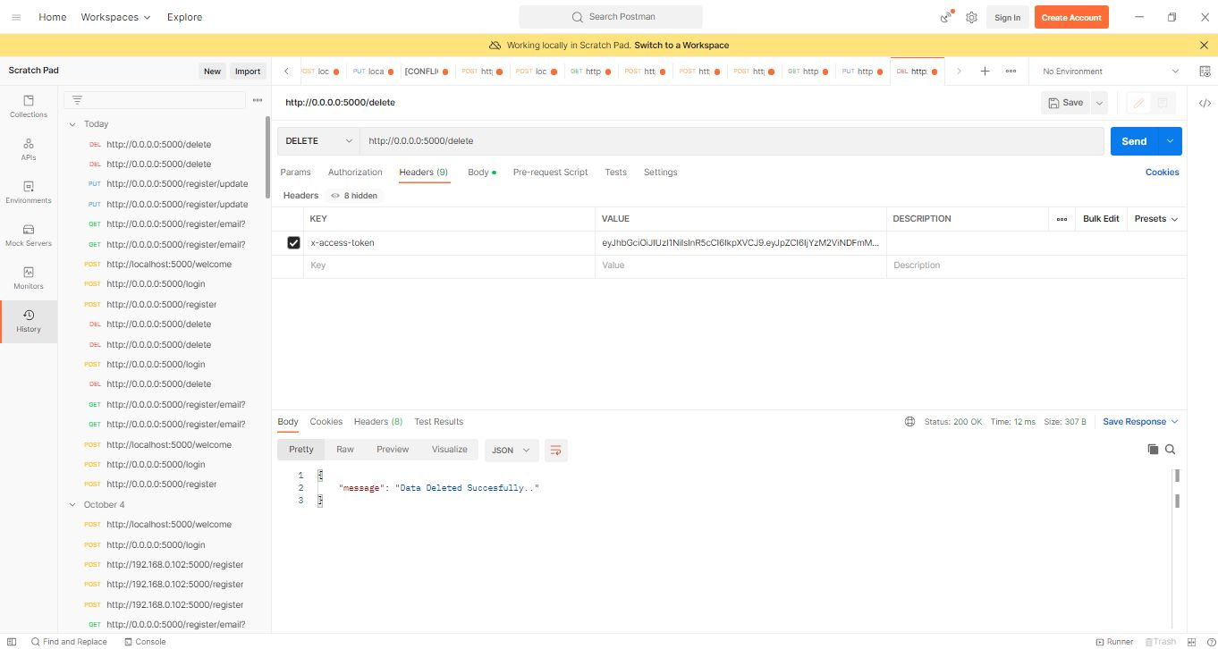

**Delete API is used to delete user data it is also execute on the base of token and then user delete data through unique id/Email in database.**

**API’s:** Delete data against Email**:**

**Descriptions:** Postman Testing,

App Listening link:http://localhost:5000**/delete**

Create your Key(x-access-token) and Value(Your Token)in the Header section, type the Email address(unique ID) and then select DELETE button(for deleting request with token verification) and click on send button,  
Response : You will find response against the deleting unique id request and **Status (Deleted Successfully) or Error Invalid Token.** Deleted data can be verified from the Database (e.i MongoDB compass)